

Aspect-Based Sentiment Analysis on Climate Change Tweets
Individual Project Report | NLP Assignment 2

Mahmuda Haque Mumu | S393941

CHARLES DARWIN UNIVERSITY
Faculty of SCIENCE and TECHNOLOGY
15/04/2026

Aspect-Based Sentiment Analysis on Climate Change Tweets
1. Introduction: 3
2. Aim of Model: 3
3. Project Scope 3
3.1 The scope of the project includes: 3
3.2 Out of Scope: 4
3.3 Assumptions: 4
3.4 Change of Scope from Assignment 1 4
4. Approach 4
4.1 Loading Data 4
4.2 Addressing Imbalanced Classes 4
4.3 Data Preprocessing Techniques 5
4.4 Extraction of Features 5
4.5 Training Models 6
4.6 Model Assessment 6
5. Data Analysis and Pre-processing 6
5.1 Pre-processing Procedures: 6
5.2 Limitation 6
6. Result: 7
7. Ethical and Societal Implications 7
8. Timeline: 7
9. Resources Used 8
References: 8
‌Appendix 8

Introduction:
With an increase in social media use by the people, there are massive amounts of textual data being generated everyday through social networking sites such as Twitter. The information collected here is very significant in terms of learning about the thoughts, emotions and opinions of the masses regarding various topics. Sentiment analysis is an aspect of natural language processing that classifies the sentiments portrayed in texts into neutral, positive and negative sentiments.
Traditional sentiment analysis does not analyze any aspect of a particular sentiment but rather determines the general sentiment that is portrayed in a certain text. This is where Aspect-Based Sentiment Analysis comes in. Although sentence-level classification of sentiments remains the prime focus of this paper, aspect-based understanding becomes possible through the preprocessing and modeling phases of ABSA.
The objective of the project is to develop a sentiment classification algorithm using Twitter data. Such systems employ machine learning techniques to classify sentiments after processing, cleaning, and structuring textual information. The use of these systems in real-life scenarios includes their use for decision-making, brand monitoring, and consumer feedback analysis.

Aim of Model:
The core idea of this model is to utilise the machine learning pipeline with the aid of NLP techniques for automated classification of tweets about climate change into positive (pro-climate change) and negative (deniers of climate change) opinions.

Possible applications of this idea may be:
- Environmental NGOs that monitor public opinions on the issue of climate change policies.
- Government departments interested in assessing their effectiveness in communication regarding climate change.
- Academics who study the dynamics of opinions and the spread of misinformation about climate change through social media platforms.
- Online news media that classify user-generated content related to environmental issues.

Project Scope

3.1 The scope of the project includes:
- Data preparation and data cleaning
- Sentiment analysis to classify positive and negative perspectives
- Extraction of features using Term Frequency-Inverse Document Frequency
- Training Support Vector Machine (LinearSVC) models
- Performance measures of the classification

3.2 Out of Scope:
- Neutral sentiment classification (not present in the dataset)
- Real-time systems implementation
- Multilingual sentiment analysis
- Deep learning models

3.3 Assumptions:
- The labels are in the dataset are accurate.
- After clean the data the models performance should be improved
- Constraints
- The elimination of neutral sentiment data limits generalization.
- Aspect-based extraction is not implemented explicitly in the system.
- Examples of noise in the Twitter dataset are slang and acronyms.
- The quality of the data impacts the performance of the model.
Although neutral data had to be removed for easy classification, the scope was almost similar.

3.4 Change of Scope from Assignment 1
For Assignment 1, my proposed was to implement an NLP-driven malicious URL detection system with adversarial robustness evaluation. However, due to the impossibility of finding a proper dataset, as well as a lack of sentiment analysis-related features, I will change the subject for the second assignment.
In the process of utilizing my existing data set regarding multiclass classification of malicious URLs, I faced issues while lemmatizing the text, especially when dealing with special characters like \, @, #, %, and others. It necessitates either deletion or proper preprocessing, which made the process complex and reduced the efficiency of the chosen methodology.

Approach
The following process is adopted in the implementation of machine learning:

4.1 Loading Data
The data will be loaded through a CSV file containing tweet sentiments and tweets. Some of the sentiments include Positive (+1), Negative (-1) and Neutral (0). The process of classification becomes much easier due to the exclusion of neutral data.

4.2 Addressing Imbalanced Classes
To focus only on the binary classification task, the neutral (0) and news (2) tweets were removed. An equal distribution of 7,980 tweets (3,990 for each category) was acquired by reducing the size of the larger positive category to be equivalent with the smaller negative category.
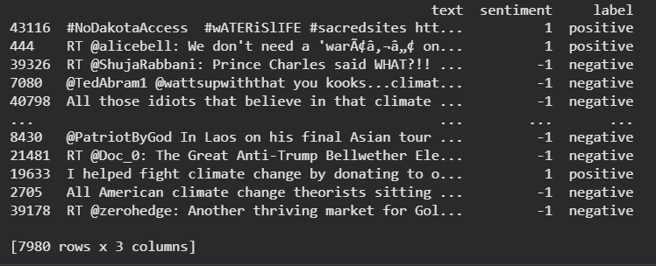

4.3 Data Preprocessing Techniques
- Various preprocessing techniques are involved, including:
- Converting text to lowercase
- Removing URLs, punctuations, and special characters
- Tokenization
- Eliminating stopwords but retaining negation words such as 'not' and 'no'
This process is vital for reducing noise and ensuring the retention of essential information.
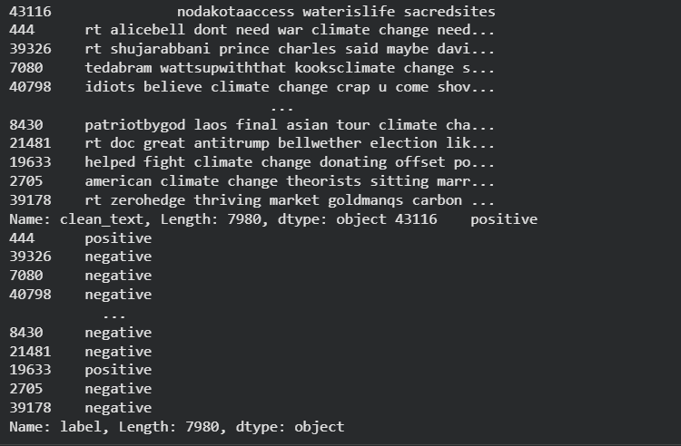

4.4 Extraction of Features
The TF-IDF vectorizer is used to convert the clean data to numeric features through the following configuration parameters:
- Max features: 8000
- N-grams range: (1, 2)
- The bigrams help in providing context and help identify phrases like “not good,” which are very important for sentiment analysis.
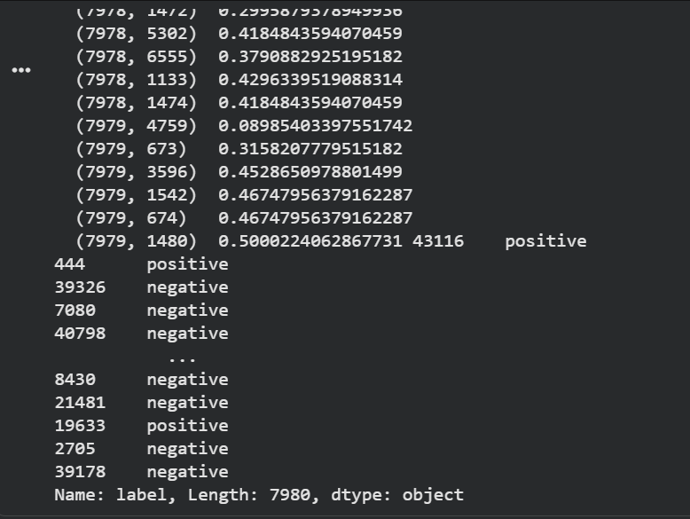

4.5 Training Models
In this case, the model that was used for performing the classification is LinearSVM. Such models are particularly efficient for dealing with high-dimensional data types such as text data. The data set was divided into training and testing sets with 80:20 proportions respectively.
4.6 Model Assessment
The model is tested using a classification report which shows: Recall Accuracy F1-score
Also, a prediction function is developed for testing the model with input words.

Data Analysis and Pre-processing
The tweets from Twitter tagged with sentiment scores form the data set. Some types of noise identified during the preliminary analysis include URLs, special characters, and inconsistent formatting.

5.1 Pre-processing Procedures:
- Discarding of records showing a neutral attitude.
- Balancing of positive and negative classes.
- Cleaning up of texts through removing unnecessary parts.
- Including negation words to preserve emotional intent.

All of the processes help significantly in enhancing the quality of the data. Despite some drawbacks related to its nature and lack of aspect annotation, the data set is suitable for sentiment classification tasks.

5.2 Limitation
- The real-life applicability is constrained by the use of binary classification alone (neutral and news categories ignored).
- Context ignorance (TF-IDF vector space model cannot detect irony, sarcasm, or figures of speech)
- Vocabulary reduction due to down sampling (over 19,000 positive instances dropped off, reducing vocabulary diversity).

Result:
The classifier is effective in sentiment analysis, based on the model used and the properties of the data set.

6.1 Performance:
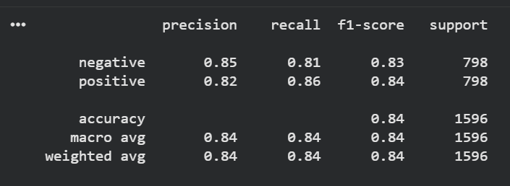
The accuracy rate of the model is 84%, with high recall and precision rates for both positive and negative sentiments. The performance of the model is even, which can be attributed to the evenness of the data set.

6.2 Example Predictions:
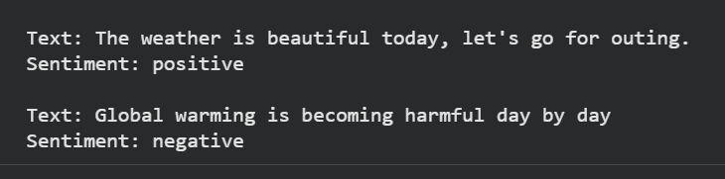
From the results, it can be concluded that despite being good at sentiment classification, the algorithm requires improvement in handling complex language structures.

Ethical and Societal Implications
Such an approach can prove advantageous for society since it would make it possible for environmental organizations to gauge the attitudes of the general population and for governments to assess their efforts to communicate on climate issues. Nevertheless, the ethics of using biased samples consisting primarily of educated Twitter users based in cities are raised. Furthermore, misclassification issues such as distinguishing between irony and sarcasm should also be taken into consideration.

Timeline:
Week 1-3 Topic Selection and Data Collection Complete
Week 4 Data Cleaning Complete
Week 5 Feature Extraction Complete
Week 6 Model Training and Evaluation In Progress
Week 7 Improvement Pending

Resources Used
Libraries:
Pandas
Numpy
Scikit-learn
NLTK
Spacy

Tools:
Python
Google Colab

Dataset:
Twitter Climate Change Sentiment Dataset from Kaggle

References:
Qian, E. (2015). Twitter Climate Change Sentiment Dataset. Kaggle.com. https://www.kaggle.com/datasets/edqian/twitter-climate-change-sentiment-dataset/data

‌Appendix
Code: https://colab.research.google.com/drive/1yEqlqLCt4VOv7RSeCNqwh0q-CQrvg5lT#scrollTo=pBG77aFwBh3J
Repository Link:
https://github.com/Mahmuda-Hoque-Mumu/PRT-597-Assignment-2

